Java Memory Management
Stack • Heap • Metaspace • Native Memory • String Pool • Garbage Collection
Interview-focused notes with practical examples, memory diagrams, GC reachability and generational collection.

1. JVM Memory Areas
The JVM uses several runtime memory areas. The Java heap is shared by application threads; each thread has its own JVM stack. Metaspace and other JVM/native allocations use native memory.
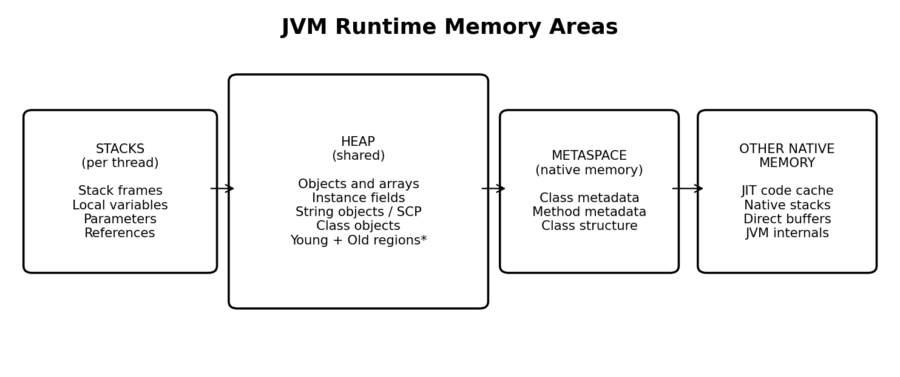
Conceptual view. Young/Old heap organization depends on the selected garbage collector.

2. Stack Memory
Each thread has its own JVM stack. A method call creates a stack frame; the frame is removed when the method invocation completes.
- Local primitive values and local reference variables (conceptually represented in the frame).
- Method parameters and per-invocation execution data.
- References to objects; the referenced objects themselves are usually on the heap.

Example
public class MemoryDemo {
public static void main(String[] args) {
int number = 10;
Employee emp = new Employee();
emp.display();
}
}
class Employee {
void display() {
int salary = 50000;
System.out.println(salary);
}
}
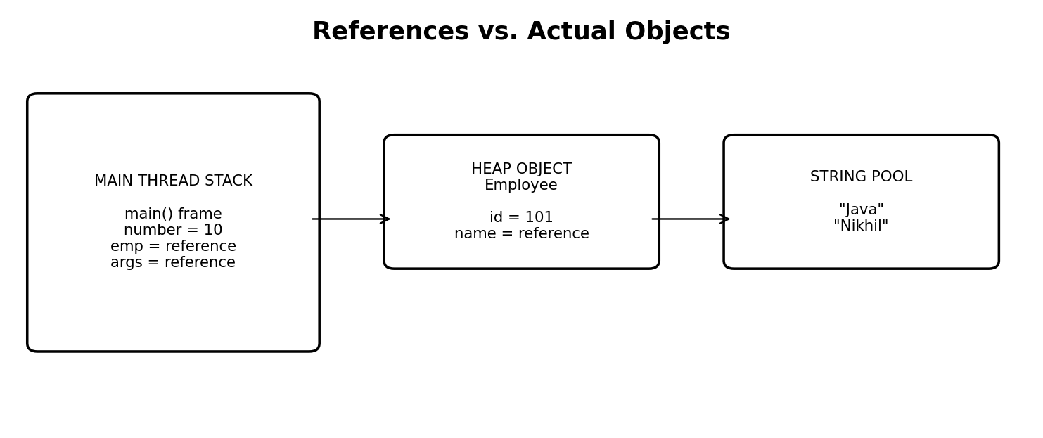
Local references are in the stack frame; the Employee and String objects are on the heap.
When display() returns, its stack frame is removed. When main() returns, its frame is removed. An object referenced only by a removed frame may become unreachable and eligible for GC.

3. Heap Memory
The heap is shared by application threads and is where Java objects and arrays are generally allocated.
- Objects created using new and arrays.
- Instance fields as part of their containing objects.
- String objects, including pooled String instances.
- java.lang.Class objects and objects referenced by static fields.
class Employee {
int id = 101; // instance field
String name = "Nikhil"; // instance reference
static String company = "Expleo"; // static field
}
Instance fields are stored within each object. Static fields belong to the class rather than each instance; in HotSpot, static field values are associated with the class mirror (the java.lang.Class object) on the heap. Class metadata itself is stored in Metaspace.

4. Metaspace
Metaspace was introduced in Java 8 and replaced PermGen. It uses native memory to store class metadata, including class structure and field/method metadata.
- Metaspace is not part of the Java heap.
- It can grow dynamically, subject to available native memory and configured limits.
- Class metadata can be reclaimed when classes are unloaded, typically when their defining class loader becomes eligible for unloading.

5. Native Memory
Native memory is memory outside the Java heap used by the JVM and native libraries. Metaspace is one use of native memory; it is not a synonym for all native memory.
- JIT compiler code cache and JVM internal structures.
- Native thread stacks and JNI/native-library allocations.
- Direct ByteBuffer data (the ByteBuffer wrapper object itself is on the heap).
ByteBuffer buffer = ByteBuffer.allocateDirect(1024);
// ByteBuffer wrapper: heap. Direct data: outside Java heap.

6. Where Are Variables, Methods and Objects Stored?
Java element | Typical location / explanation
Local primitive variable | Method stack frame (conceptually; JIT may optimize).
Local reference variable | Stack frame; refers to an object, commonly on heap.
Method parameters | Method stack frame (implementation may optimize).
Instance fields | Inside the object in heap.
Static fields | Associated with class; HotSpot class mirror on heap.
Object / array created with new | Generally heap; JIT may eliminate/scalar-replace allocation.
String object / String Constant Pool | Heap; pooled strings are ordinary String objects.
Class metadata / method metadata | Metaspace / JVM class metadata structures.
Method execution | Stack frame for each active invocation.
JIT compiled machine code | Native memory code cache.
Native thread stack / direct buffer data | Native memory.

The JVM specification defines logical runtime areas, not mandatory physical placement for every local variable. JIT compilation can optimize, move or eliminate storage while preserving program behavior.

7. String Constant Pool (SCP)
The String Constant Pool allows identical string literals to share pooled String instances. Since Java 7, the pool is maintained on the heap.
String s1 = "Java";
String s2 = "Java";
String s3 = new String("Java");
System.out.println(s1 == s2); // true
System.out.println(s1 == s3); // false
System.out.println(s1.equals(s3)); // true
s1 and s2 refer to the same pooled String. new String("Java") creates a distinct String object; the literal used in the constructor refers to the pooled string.

8. What Is Garbage Collection?
Garbage Collection (GC) is JVM-managed memory reclamation. It identifies heap objects that are no longer reachable from GC Roots and reclaims their memory. Being eligible for GC does not mean collection happens immediately.

9. GC Roots and Reachability
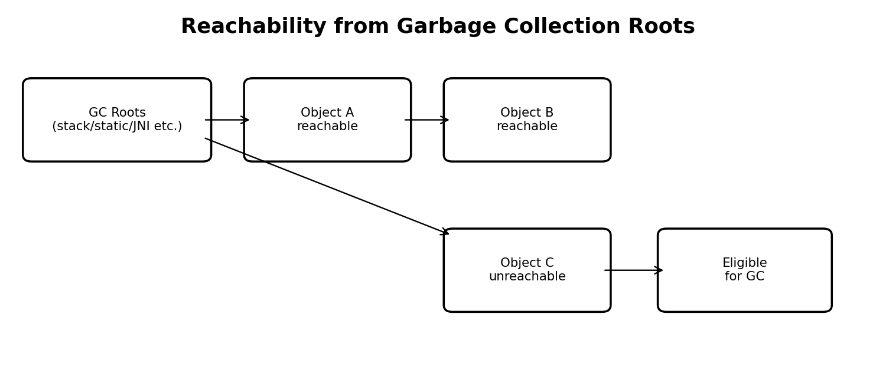
Objects reachable from GC Roots are live; unreachable objects can be reclaimed.
Typical GC Roots include references in active thread stacks, references from static fields of loaded classes, JNI handles and JVM-internal references. The exact root set depends on JVM implementation and execution state.
Employee emp = new Employee();
emp = null;
// If no other reachable reference points to the Employee,
// the object becomes eligible for garbage collection.

10. Generational Heap Model
Many collectors use generational ideas because many objects become unreachable quickly. The traditional model describes Young Generation and Old Generation.
- Young Generation: commonly described as Eden plus two Survivor spaces (S0 and S1). New objects are often allocated in Eden.
- Survivor spaces: objects that survive a young collection may be copied between survivor spaces.
- Old Generation: objects that remain live may be promoted here. Some objects may be allocated directly into old regions.
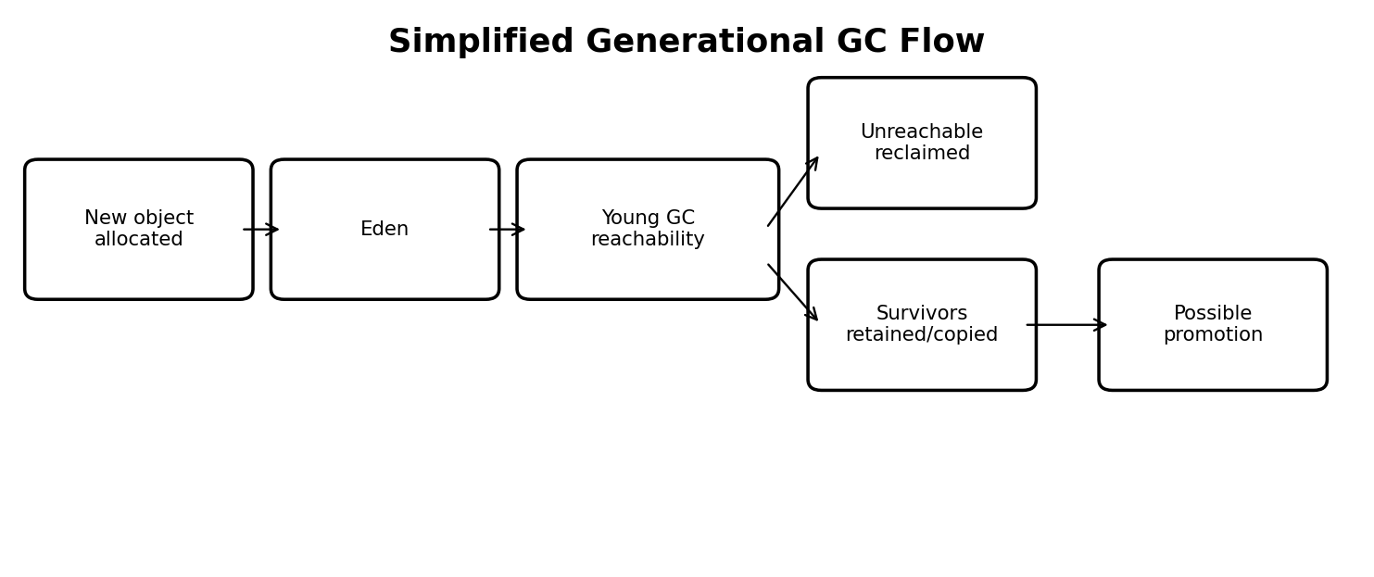
Simplified illustration only. Actual algorithms and heap layouts vary by collector.
Promotion is not governed by one universal fixed number of GC cycles. It depends on the collector, object age, allocation pressure and runtime policy.

11. Simplified Garbage Collection Cycle
- Objects are allocated, commonly in Eden in generational collectors.
- When collection is needed, the collector identifies live objects using reachability from roots.
- Unreachable objects are reclaimed.
- Surviving objects may be copied or otherwise retained; some may later be promoted to old regions.
- Old-generation or mixed collections occur according to the collector's policy and memory pressure.
Details differ significantly: G1 uses heap regions and mixed collections; ZGC and Shenandoah use different low-pause strategies. Not every collector follows a simple Eden → Survivor → Old diagram.

12. GC Types and Common Collectors
Term / collector | Meaning
Young GC | Collection focused on young-generation regions in generational collectors.
Old-generation collection | Collection of old-generation regions; terminology varies by collector.
Full GC | Broad collection of the Java heap; may also perform class unloading and other cleanup.
Serial GC | Uses a single GC thread for collection work.
Parallel GC | Uses multiple GC threads, emphasizing throughput.
G1 GC | Region-based collector designed to balance throughput and pause-time goals.
ZGC | Low-latency collector designed for very short pauses.
Shenandoah | Low-pause collector using concurrent work.

Minor GC and Major GC are common terms, but their precise meaning is not uniform across all JVM collectors. Prefer collector-specific terminology in diagnostics and documentation.

13. Does GC Work on Stack, Heap, Metaspace and Native Memory?
Memory area | GC relationship
Stack | Stack frames are popped when methods return; GC does not collect stack frames as heap objects.
Heap | Main area managed by object garbage collectors.
Metaspace | Class unloading can reclaim class metadata when class-loader conditions allow it.
Native memory | Not generally reclaimed by Java heap GC; native resources follow their own lifecycle.
String Constant Pool | Pooled String objects are heap objects and can be collected when unreachable.

14. System.gc()
Employee emp = new Employee();
emp = null;
System.gc(); // Requests GC; does not guarantee immediate collection.
- System.gc() is a request/hint to the JVM, not a guarantee.
- The request may be ignored or disabled.
- Application correctness must never depend on System.gc().

15. Complete JVM Memory Architecture
Review diagram of stack, heap, Metaspace and other native memory.

16. Interview Questions and Answers
Where are objects created? Generally in heap memory; JIT optimizations may eliminate or scalar-replace some allocations.
Where are local variables stored? In a method's stack frame conceptually; JIT may optimize their physical storage.
Where are static variables stored? They are associated with the class. In HotSpot, static field values are stored in the heap class mirror.
Where is the String Constant Pool? On the heap since Java 7.
Where is main() stored? Class metadata/bytecode is maintained by the JVM; execution of main() uses a stack frame on the main thread's stack.
Where are instance variables stored? Inside their containing objects in heap memory.
Does GC clean stack memory? No. Stack frames are removed as method calls return.
Can GC collect an object referenced by a static field? Not while that reference remains reachable from a GC Root. If the reference is removed and the object becomes unreachable, it may be collected.
What replaced PermGen? Metaspace, introduced in Java 8.
Can System.gc() force collection? No. It requests collection but does not guarantee it.

17. Final Revision Table
Concept | Memory area
Local primitive / reference variables | Stack frame (conceptually)
Method parameters and active frames | Stack
Instance fields | Heap, inside object
Static fields | Associated with class; HotSpot class mirror on heap
Objects and arrays | Heap
String objects / SCP | Heap
Class metadata | Metaspace
JIT compiled code | Native memory / code cache
Native thread stacks and direct buffer data | Native memory
Unreachable heap objects | Eligible for GC

Key Interview Statement
Java uses Stack Memory for method execution, Heap Memory for objects and arrays, Metaspace for class metadata, and Native Memory for JVM and native allocations. Garbage Collection primarily reclaims unreachable heap objects and may also participate in class unloading to reclaim Metaspace.
Revision priority: Understand references versus objects, static versus instance fields, the String Constant Pool, GC Roots, reachability and differences between collector algorithms.

